DHCP CONFIGURATION THEORY
- In Cisco Packet Tracer, set up a simple network with one DHCP server and two client PCs. Configure the DHCP server to assign IP addresses automatically, then verify on each PC that it receives a different IP address from the DHCP pool.
Answer
Short DHCP Lab in Packet Tracer
Topology: 1 Server-PT → 1 Switch → 2 PCs (PC0, PC1).
1) Set server static IP
- Server → Desktop → IP Configuration
  - IPv4: 192.168.1.1
  - Mask: 255.255.255.0
  - Gateway: 192.168.1.1
2) Enable DHCP on server
- Server → Services → DHCP → On
- Add pool:
  - Name: LAN-Pool
  - Gateway: 192.168.1.1
  - Start IP: 192.168.1.10
  - Mask: 255.255.255.0
  - Max users: 50 → Add
3) Set PCs to DHCP
- Each PC → Desktop → IP Configuration → select DHCP.
- Wait; they auto-fill (e.g., PC0 = 192.168.1.10, PC1 = 192.168.1.11).
4) Verify different IPs
- On each PC → Desktop → Command Prompt → ipconfig
- Confirm IPv4 addresses are different (e.g., .10 and .11)

- Draw a sequence diagram (hand-drawn or digital) that clearly shows each step of the DHCP process: Discover, Offer, Request, and Acknowledge, labeling the sender and receiver at each stage. Use arrows to show the direction of each message between client and server.
Answer
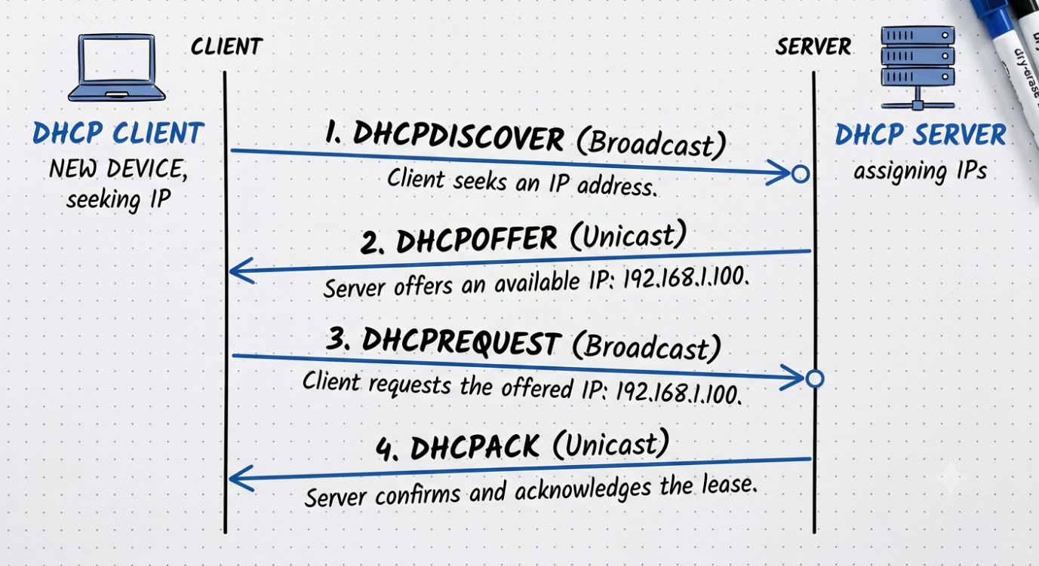
- Change the DHCP pool range on your Cisco Packet Tracer DHCP server so that only one IP address is available. Add two PCs and observe what happens when both try to get an IP address. Take a screenshot of the result and explain in 2-3 lines why only one PC succeeds.
Answer
Step-by-Step Instructions
- Configure the DHCP Server:
  - Double-click your DHCP Server, go to the Services tab, and select DHCP.
  - Set the Start IP Address to 192.168.1.100 and the Maximum number of Users to 1 (or set the start address to 192.168.1.100 and the end address/mask restriction so only one address is available). Save the configuration.
- Connect and Test PCs:
  - Add PC0 and PC1 to your topology and connect them to the switch/DHCP server.
  - On PC0, go to Desktop > IP Configuration and select DHCP. It will successfully acquire 192.168.1.100.
  - On PC1, go to Desktop > IP Configuration and select DHCP. It will fail and receive an APIPA address (169.254.x.x).
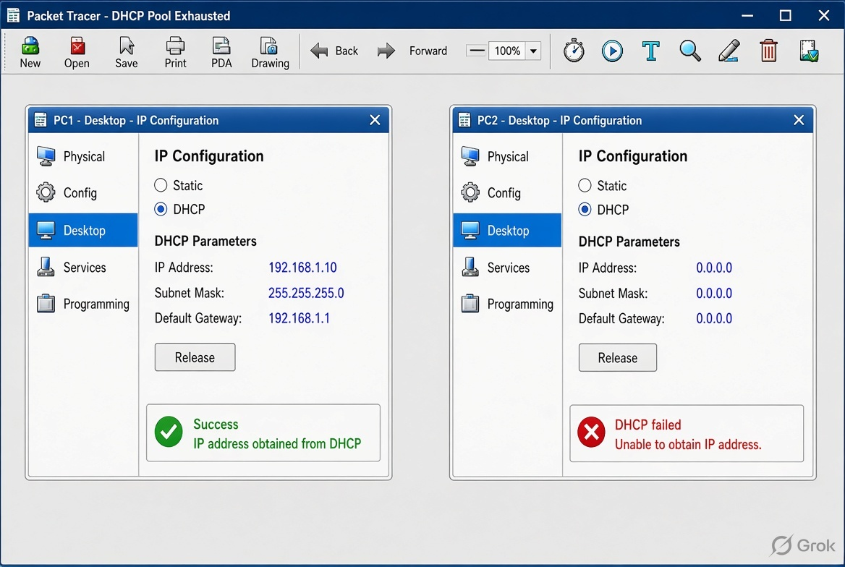

- Simulate a Zomato-style restaurant Wi-Fi scenario in Cisco Packet Tracer: configure a DHCP server to provide IP addresses to both a laptop and a smartphone (use a generic PC as smartphone). Show the assigned IPs and explain why DHCP is useful in this situation.

Answer

Topology in Packet Tracer
- 1 × Server-PT → acts as the restaurant’s WiFi DHCP server
- 1 × PC-PT → Laptop
- 1 × PC-PT → Smartphone (generic PC)
- 1 × 2960 Switch (or Access Point if you prefer wireless)
Connections (Copper Straight-Through):
Server → Switch Fa0/1
Laptop → Switch Fa0/2
Smartphone → Switch Fa0/3

DHCP Server Configuration
- Server → Desktop → IP Configuration
  - Static IP: 192.168.10.1
  - Subnet Mask: 255.255.255.0
- Server → Services → DHCP → turn On
  - Pool Name: Zomato_WiFi
  - Default Gateway: 192.168.10.1
  - Start IP Address: 192.168.10.100
  - Subnet Mask: 255.255.255.0
  - Maximum Number of Users: 50
  - Click Add

Client Configuration
- On both the Laptop and Smartphone:
Desktop → IP Configuration → select DHCP

Assigned IP Addresses
After a few seconds both devices automatically receive unique addresses from the restaurant’s DHCP pool:
